Extraction, Transformation, and Load (ETL) Project

Team Members: Austin Little, Meryem ozcelik, kimberly gordon   
Summary

11/11/2018

## Topic for review

* <https://github.com/austinlittle1/ETLproject>
* How does the climate impact a person’s overall health?
* Expected Outcome – Type of climate based on the location is directly related to a person’s health. However, there are environmental issues that can positively / negatively change the results.
* Specific integration points will be needed to clearly understand the impacts.

## Project Scope

* For the team to find manageable files to review, analyze and share results after performing extraction, transformation and loading in database for review.
* Very quick project with less than two weeks to review and work with team.

## Approach

* Team decided on a general topic for analysis.
* Researched the availability of data.
* Analyzed possible share information that can be used as integration points.
* Performed various Python-Pandas analysis on the data to prepare the integration for formal review.

## Finding Data

* Resources used to find the appropriate data considered and included
  + [data.world](https://data.world/)
  + [kaggle](<https://www.kaggle.com/>)
  + APIs
  + Data scraping
  + Large Data Sets from:
    - National Center for Health Statistics
    - Environmental Protection Agency
    - Centers for Disease Control and Prevention

## Finding Data

* Resources used to find the appropriate data considered and included
  + [data.world](https://data.world/)
  + [kaggle](<https://www.kaggle.com/>)
  + APIs
  + Data scraping
  + Large Data Sets from:
    - National Center for Health Statistics
    - Environmental Protection Agency
    - Centers for Disease Control and Prevention

## Import – Extraction

After finding the data needed, more research was done to find files needed for the research, most data was found in CSV format from the respective sites. To start the extraction – transformation, files were moved to Python-Pandas. All data was considered production data. Test data was not considered for this project review. All files had some type of design specification or data model. In some cases, fields have derived information. In those situations, the data was not used in the research. In the detail ETL for each file, handling of derived data is explained.

## Details of ETL

* File Name
* Summary of type of Data
* Source of Data
* Specific parameters used in integration
* File format (fixed length, comma separated, etc.)
* ETL needed before integrating all files
  + Cleaning
  + Joining
  + Filtering
  + Aggregating
* Final tables (relational or non-relational)

**File – NCHS – Leading Causes of Death: United States**

## Metadata Updated: August 20, 2018

This dataset presents the age-adjusted death rates for the 10 leading causes of death in the United States beginning in 1999. Data are based on information from all resident death certificates filed in the 50 states and the District of Columbia using demographic and medical characteristics. Age-adjusted death rates (per 100,000 population) are based on the 2000 U.S. standard population. Populations used for computing death rates after 2010 are postcensal estimates based on the 2010 census, estimated as of July 1, 2010. Rates for census years are based on populations enumerated in the corresponding censuses. Rates for non-census years before 2010 are revised using updated intercensal population estimates and may differ from rates previously published. Causes of death classified by the International Classification of Diseases, Tenth Revision (ICD–10) are ranked according to the number of deaths assigned to rankable causes. Cause of death statistics are based on the underlying cause of death. SOURCES CDC/NCHS, National Vital Statistics System, mortality data (see <http://www.cdc.gov/nchs/deaths.htm>); and CDC WONDER (see [http://wonder.cdc.gov](http://wonder.cdc.gov/)).

REFERENCES

National Center for Health Statistics. Vital statistics data available. Mortality multiple cause files. Hyattsville, MD: National Center for Health Statistics. Available from: <https://www.cdc.gov/nchs/data_access/vitalstatsonline.htm>.

Murphy SL, Xu JQ, Kochanek KD, Curtin SC, and Arias E. Deaths: Final data for 2015. National vital statistics reports; vol 66. no. 6. Hyattsville, MD: National Center for Health Statistics. 2017. Available from: <https://www.cdc.gov/nchs/data/nvsr/nvsr66/nvsr66_06.pdf>.

URL: <https://data.cdc.gov/api/views/bi63-dtpu/rows.csv?accessType=DOWNLOAD>

**From the dataset abstract**

This dataset presents the age-adjusted death rates for the 10 leading causes of death in the United States beginning in 1999. Data are based on information from all resident death information.

Source: [NCHS - Leading Causes of Death: United States](https://catalog.data.gov/dataset/age-adjusted-death-rates-for-the-top-10-leading-causes-of-death-united-states-2013)

## Summary of ETL work

* Reviewed file concentrating on: data available in file, years available and any missing values…This resolved whether the data was robust for ETL
* Snapshot of the details. Over 10,000 rows of data was available.

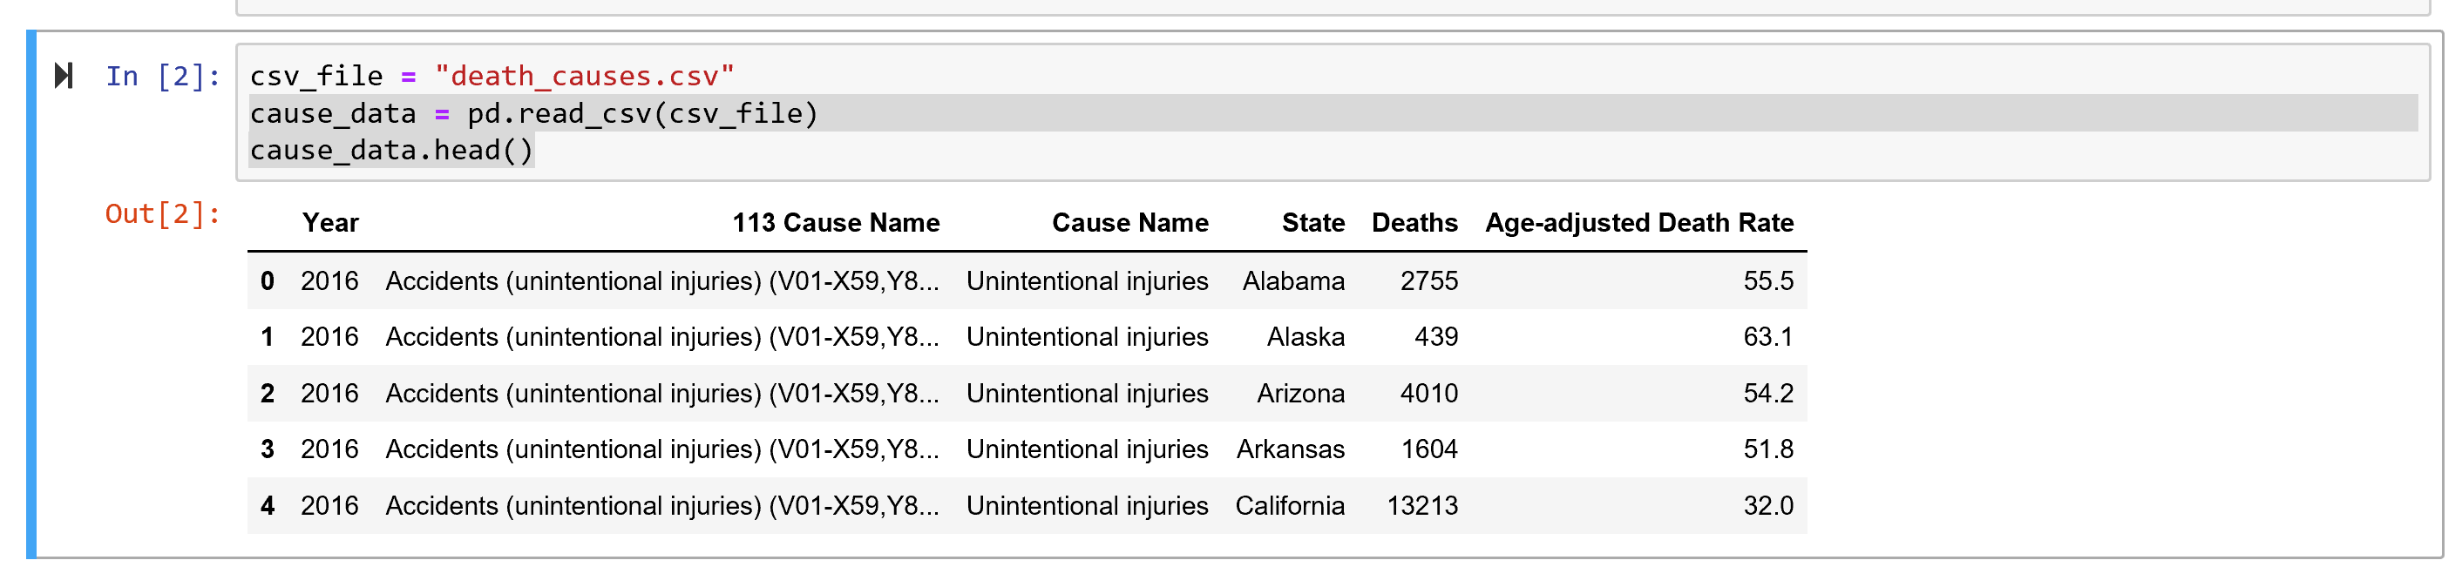

* Cause of death included:
  + 'Unintentional injuries'
  + 'All causes'
  + "Alzheimer's disease"
  + 'Cancer'
  + 'CLRD' (Chronic Lower Respiratory Disease)
  + 'Diabetes',
  + 'Heart disease',
  + 'Influenza and pneumonia',
  + 'Kidney disease',
  + 'Stroke',
  + 'Suicide'
* More Panda work to use data of 2011; survey other specific diseases to verify that data was available for each state
* Snapshot of 2011 for Cancer
* 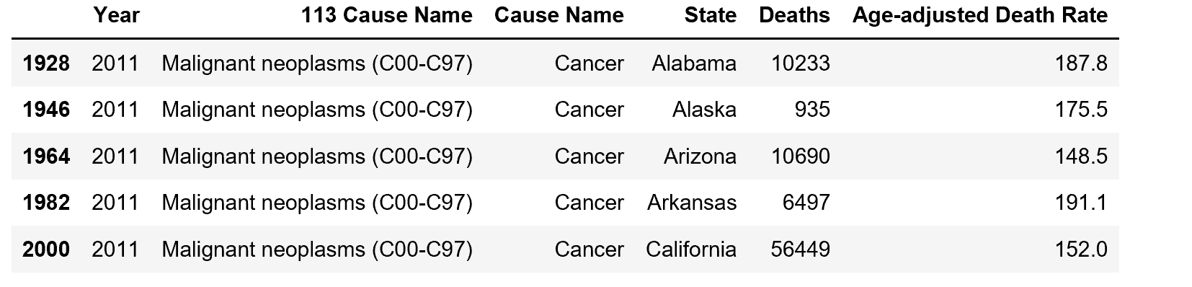
* Review possibility of an additional file with air quality data. A better file was found and this work was not used. Charts for the data can be found in Jupiter file etl_project.ipynb in Github.
* 